

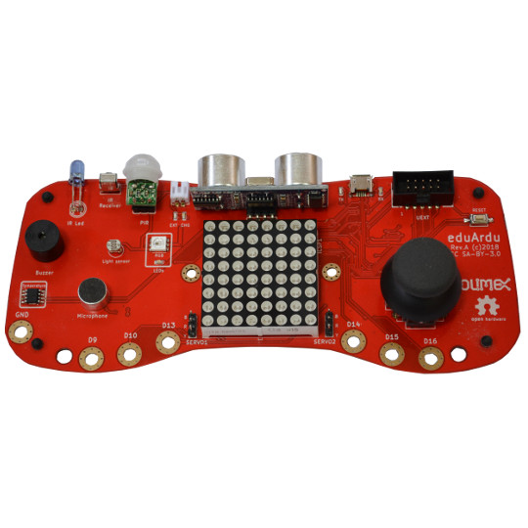

First steps with
Scratch 3 and eduArdu

Rev.1 July 2019
olimex.com

Step 1 prepare eduArdu

What you need is eduArdu or eduArdu-QS Open Source Hardware board from Olimex.
Then you need to program it with example #20 from GitHub
20_eduArdu_Makey-Makey

The code program eduArdu when sense touch to D9-D16 to send these keys:
D9 - „a“
D10 - „s“
D13 - „d“
D14 - „f“
D15 - „g“
D16 - „w“
Joystick Up – Key-Up
Joystick Down – Key-Down
Joystick Left – Key-Left
Joystick Right– Key-Right
Joystick Button – Space

Note that you can re-define any of these in the code if you need!

Step 2 configure Scratch3

Go to Scratch 3 web site:

https://scratch.mit.edu/

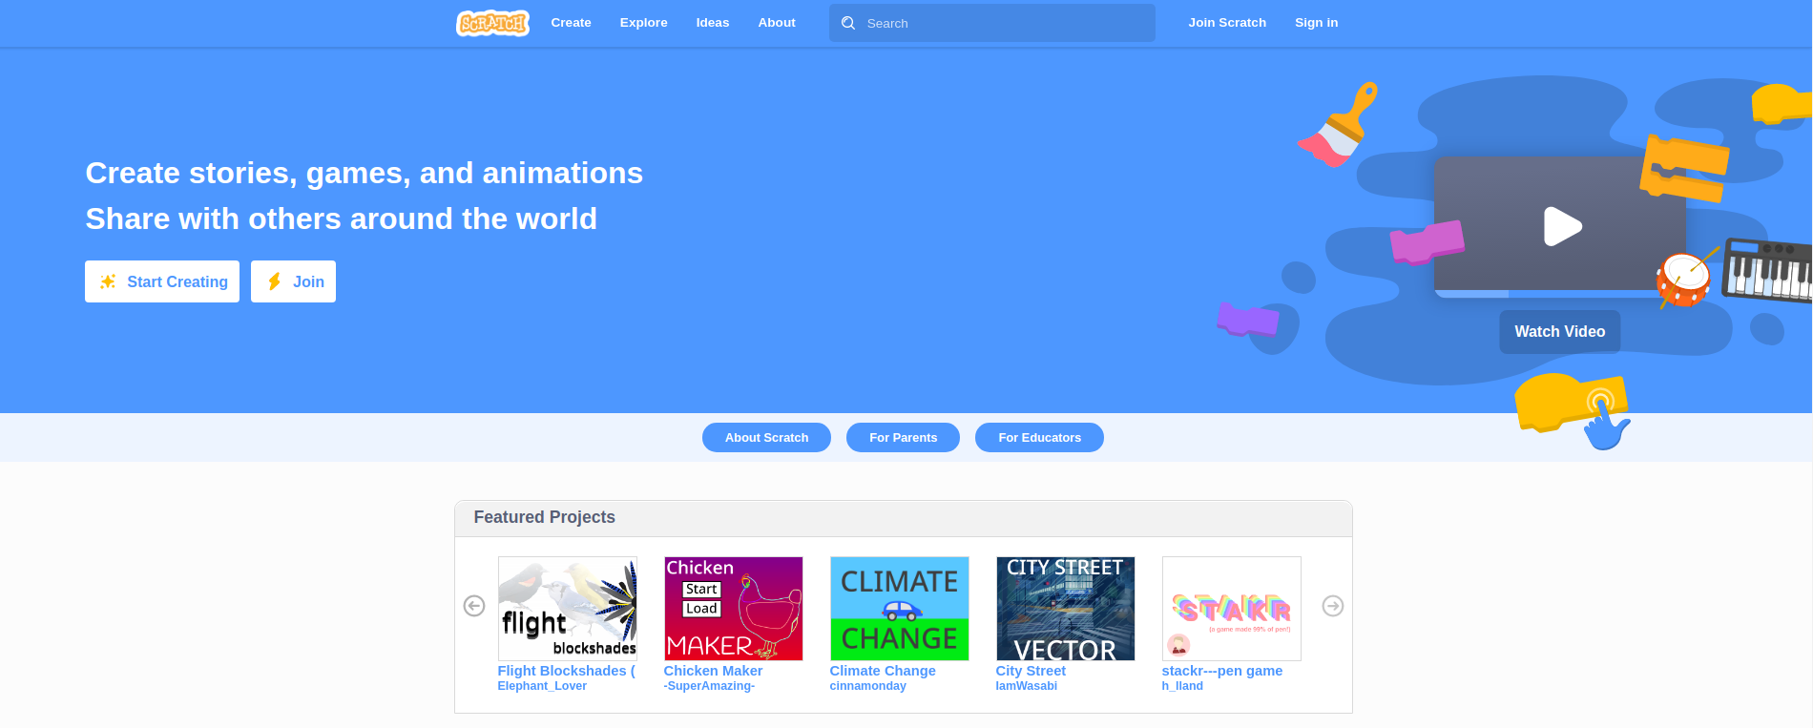
Click on „Start Creating“, you will see project page:

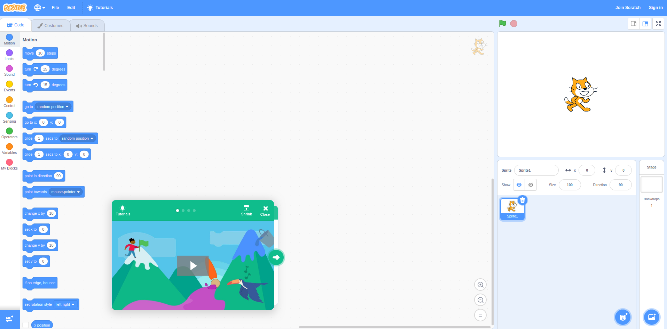

Click on Down Left corner „Add-Extension“ icon:

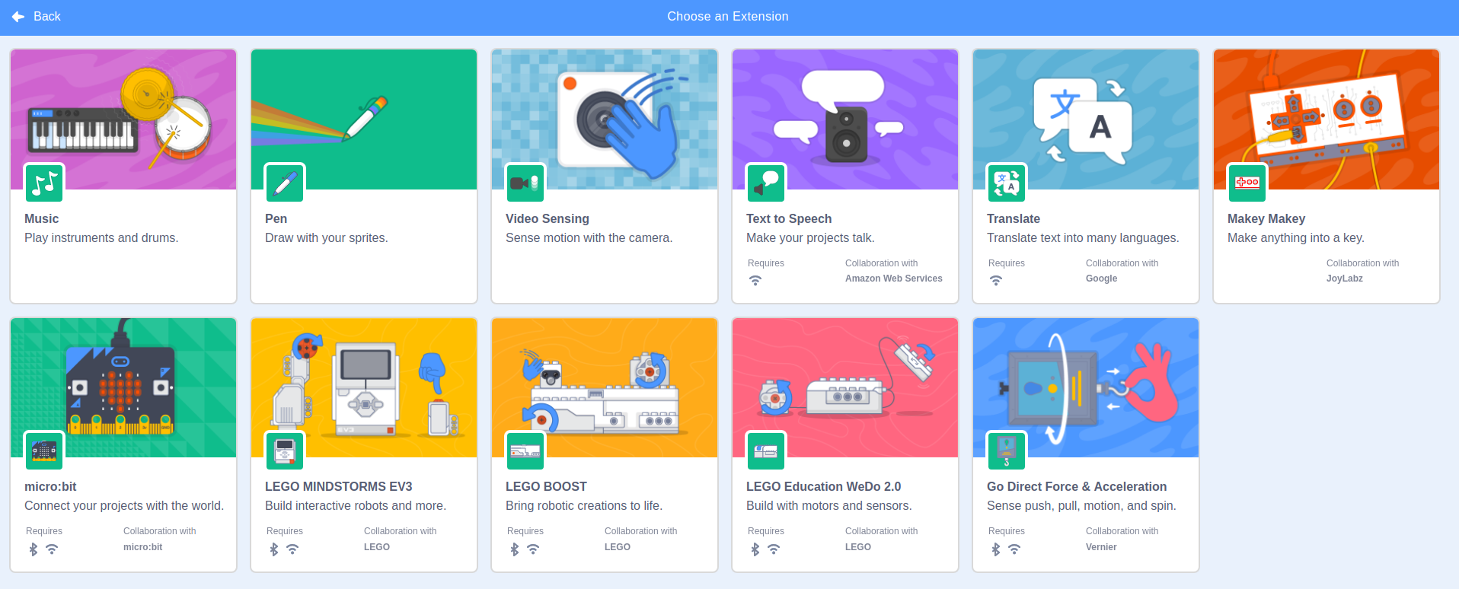
Select Makey Makey , when yo ugo bsck you will see new MakeyMakey blocks:

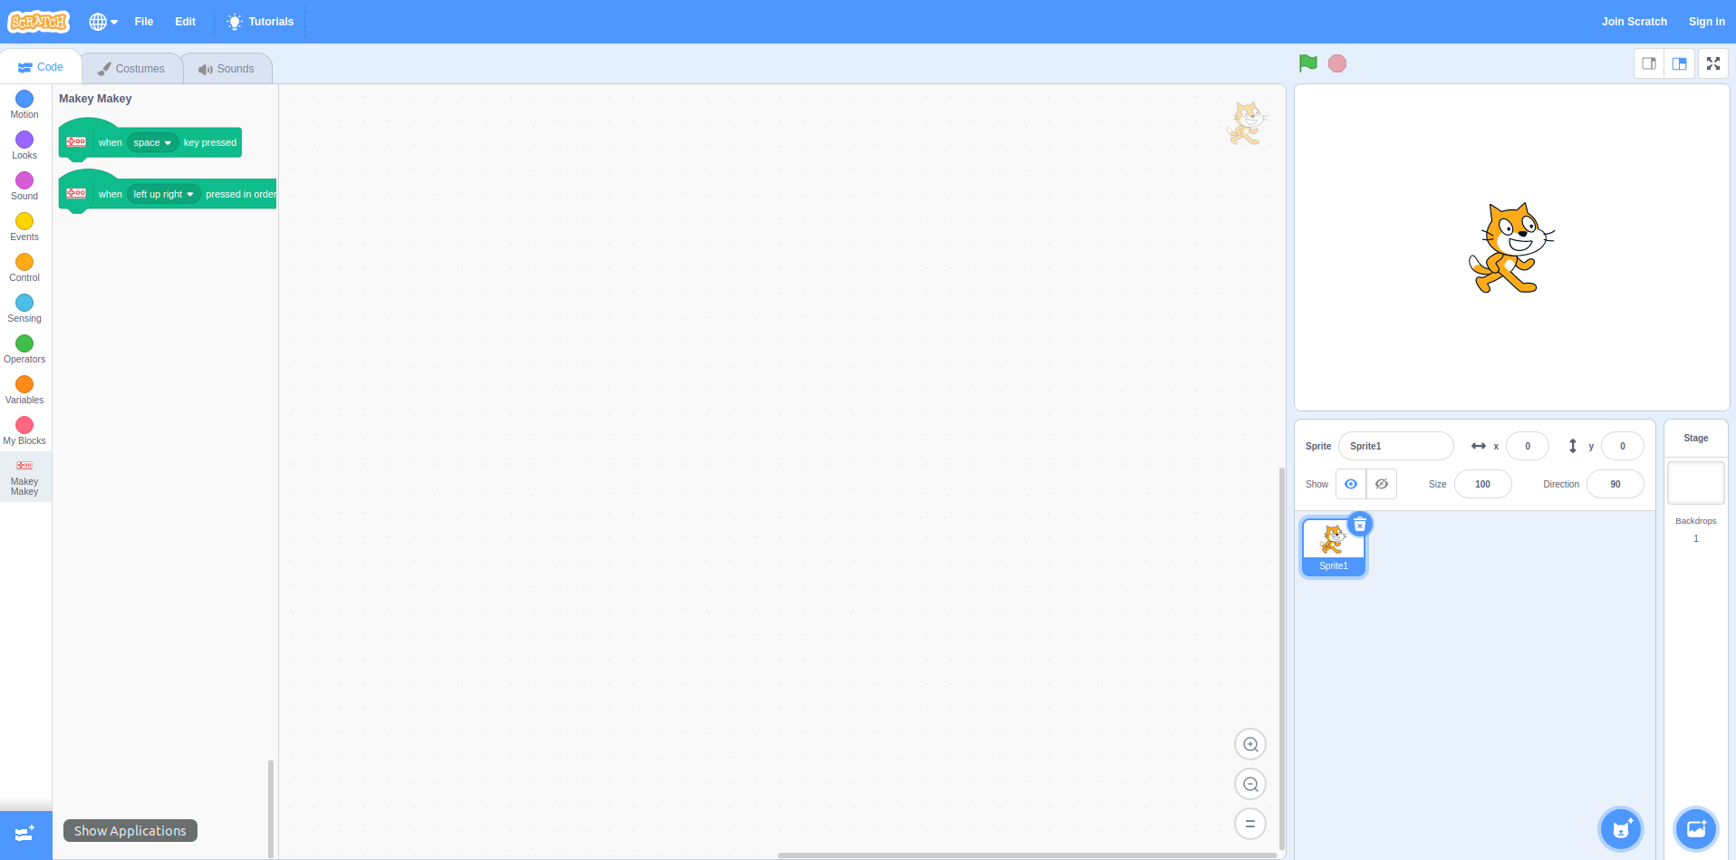

Step 3 write your own program

Now you can make your program using MakeyMakey blocks.
The program below does this: when D9 is touched the Cat will say „Hello“, when D10 is touched the Cat say „Hmm“, when D13 is tpoouched Meow sound is payed.

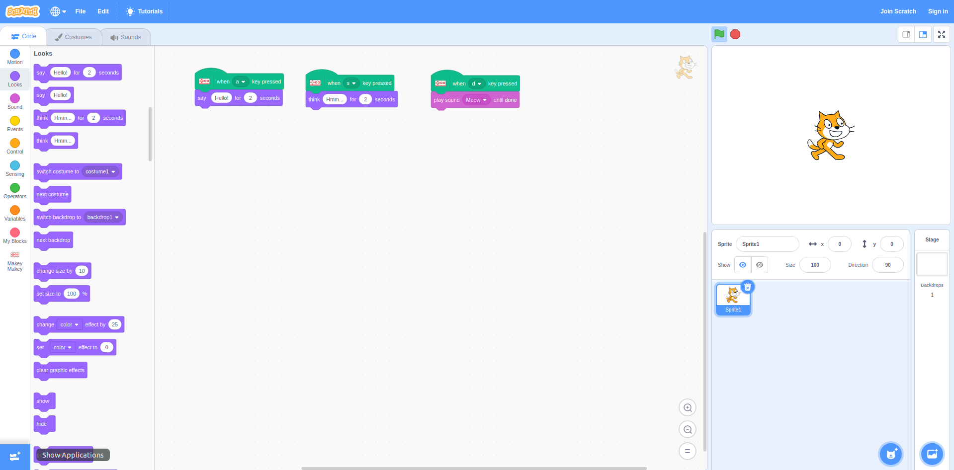

Here you can see this in action: https://youtu.be/GwdAzChfQ9Y

Have fun!!

